2-Mode Network Analysis using the Island Method

Network Overview

Original Network:
- Nodes: 899
- Edges: 7,046
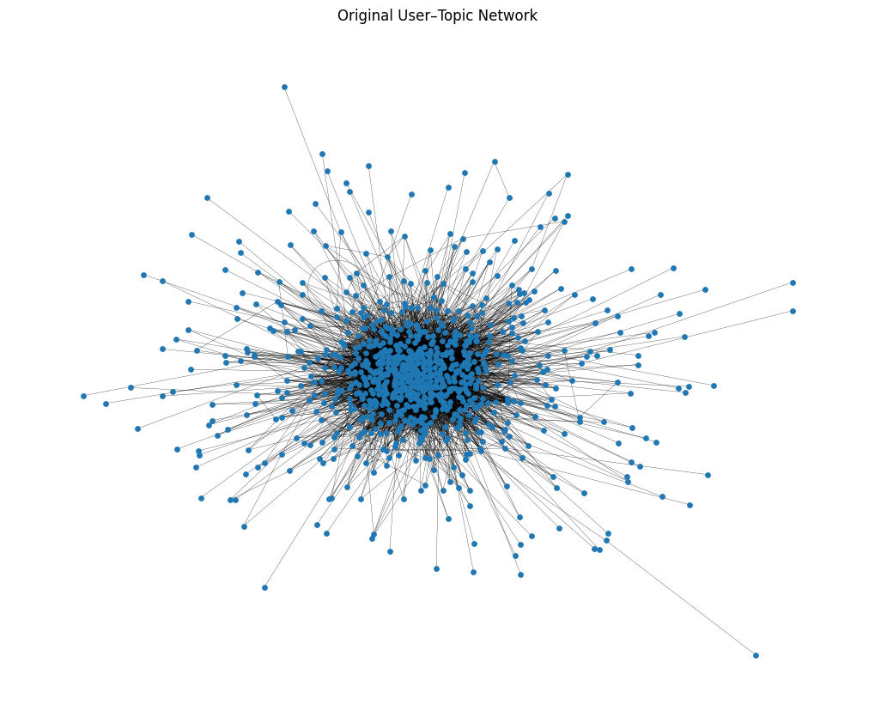
Reduced Network (Island Method):
- Nodes: 323
- Edges: 886

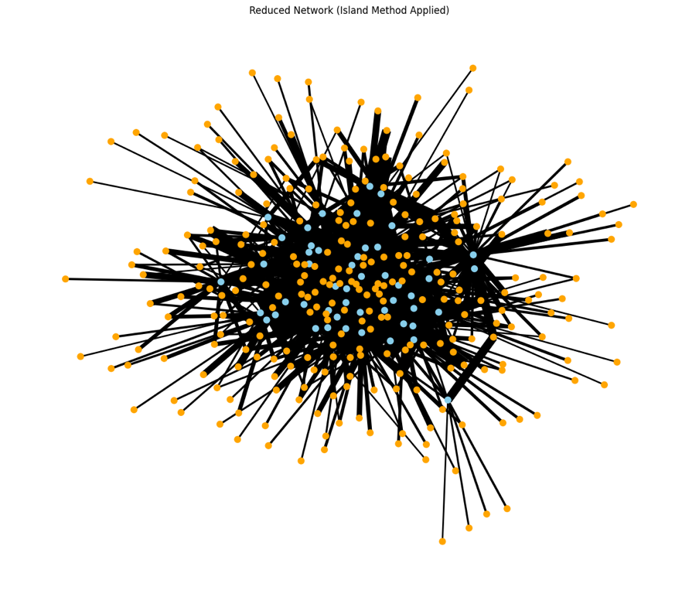
Because of the original network's extreme density, it is challenging to find significant structures. The network was much reduced, enhancing interpretability, after the island approach (weight ≥ 5) was applied, and highly active users were filtered out.

Important Takeaways

Group of Users
Core participants and potential influencers are represented by highly connected users (e.g., 100, 67). These users serve as intermediaries between clusters and link to various topics.

Subject Group
Dominant themes are represented by often related topics. Certain topics serve as hubs, connecting numerous individuals, and highlighting well-liked topics.

Structure of the Network
There are less noise, core hubs, and more distinct clusters in the reduced network. Core interactions are represented by the dense center, and niche issues are indicated by the periphery nodes.

Centrality Perspective
Top central nodes include:
- User 100 (0.205)
- User 67 (0.199)
This suggests that the network is dominated by a limited number of users, demonstrating uneven levels of engagement.

In conclusion
By eliminating weak links, the island approach efficiently reduces the bipartite network. This makes it easier to identify important subjects, influential users, and community structures.

References
Wasserman, S., & Faust, K. (1994). Social network analysis: Methods and applications. Cambridge University Press.
Galanopoulog. (2024). DATA620 Project 2. GitHub repository.

